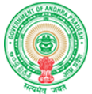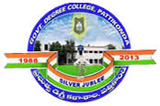**Government Degree College**

**ACCREDITED BY NAAC WITH ‘B’ GRADE** **Pattikonda,Kurnool (Dt),A.P.518380.**

**Dr R Madhuri ,**

**Principal ,**

**The institution reviews its teaching learning process, structures & methodologies of operations and learning outcomes at periodic intervals through IQAC set up as per norms and recorded the incremental improvement in various activities**

**Regular institutional reviews of IQAC's teaching and learning processes, operational structures and methods, and learning outcomes are reviewed by**

**• Internal Academic Review Team.**

**• Subject review involving students and teachers.**

**• CPDC, IQAC, and staff meetings.**

**• District-level oversight by the District Resource Center (DRC).**

**• Review by his CCE via live video conference and conference call.**

**• Peer review by A.P, CCE Academic Advisor during academic review.**

**Individual Teacher Annual Performance Indicator (API) Evaluation, CCE, for Curriculum Trading by A.P**

**Teachers are given autonomy regarding the teaching and learning process, but their strategies are actively guided by different levels of control mechanisms, with an amplifying effect on curricular trade.**